Conference Paper Title*
*Note: Sub-titles are not captured in Xplore and should not be used

1st Prajyot Kumar
Dept. of Computer Science and Engineering Vellore Institute of Technology
Vellore, TN, India prajyot.kumar2025@vitstudent.ac.in

3rd Shikhar Tandon
Dept. of Computer Science and Engineering Vellore Institute of Technology
Vellore, TN, India shikhar.tandon2025@vitstudent.ac.in
2nd Kshitij Priyankar
Dept. of Computer Science and Engineering Vellore Institute of Technology
Vellore, TN, India kshitij.priyankar2025@vitstudent.ac.in

4th Dr. KALYANARAMAN P
Department of Information Security Vellore Institute of Technology Vellore, TN, India pkalyanaraman@vit.ac.in

Abstract—Accurate time series forecasting remains a funda- mental challenge in data-driven decision-making, particularly for domains with nonlinear patterns and temporal dependencies. The presented study proposes a hybrid forecasting framework that combines the trend-seasonality decomposition of Facebook Prophet with a Long Short-Term Memory network to model both the deterministic and residual temporal dynamics. The entire workflow proceeds with structured data preprocessing and baseline modeling using Prophet, further followed by residual learning through an LSTM to refine predictions. Model inter- pretability and uncertainty quantification are integrated using SHAP-based feature importance and probabilistic confidence intervals for providing further insight into model reliability and its influencing factors. The benchmark of the proposed hybrid Prophet-LSTM architecture is done against different baseline models based on standard evaluation metrics, outperforming them with substantially higher accuracy and robustness of forecasts. This not only improves predictive precision but also offers interpretable and uncertainty-aware forecasts, making the approach suitable for a wide range of real-world applications that require both accuracy and transparency.
Index Terms—Time Series Forecasting, Prophet, LSTM, Hy- brid Modeling, Uncertainty Quantification, SHAP Interpretation, Deep Learning, Model Evaluation, Explainable AI (XAI), Data Science, Predictive Analytics, Machine Learning, Future Fore- casting, Model Comparison, Performance Metrics

Abbreviations and Acronyms
- Abbreviations and acronyms are defined the first time they occur in this paper for clarity and precision. The following are some of the commonly used terms throughout this study:
- LSTM is a kind of RNN structure that is able to learn long- term dependencies in sequential data. In this work, it is used to model time series forecasting nonlinear residual patterns.
- MAE stands for Mean Absolute Error. It is the average magnitude of errors in a set of forecasts, without reference to sign.

Identify applicable funding agency here. If none, delete this.
- RMSE (Root Mean Squared Error): A performance metric that determines the square root of the average squared differences between predicted and observed values, giving more emphasis to large errors.
- MAPE (Mean Absolute Percentage Error): This is a relative error measure that, for a given dataset, expresses the average absolute prediction error as a percentage of the actual values, giving an interpretable scale of accuracy.
- XAI: Explainable Artificial Intelligence is a set of tech- niques aimed at making machine learning models more in- terpretable, transparent, and understandable to human users.
- SHAP (SHapley Additive exPlanations): An interpretability technique based on cooperative game theory to quantify the contribution of each feature to the model’s predictions.
- Prophet: A forecasting tool developed by Meta, treats the data with an additive decomposition of trend, seasonality, and holidays.
- RNN: A recurrent neural network is a class of artificial neural networks where connections between nodes form directed cycles, enabling temporal sequences to be modeled.
- Artificial Intelligence: A field of study that develops systems that can perform tasks normally requiring human intelli- gence, such as learning, reasoning, and problem-solving.
- Central Processing Unit (CPU): This denotes the main processing element of a computer that executes instructions and controls operations.
- GPU: A processor that specializes in swiftly processing dif- ficult mathematical computations. GPUs are most frequently used to accelerate deep learning applications.
- SI (Syste`me International d’Unite´s): The International Sys- tem of Units used for measurement consistency in scientific communication.
  - Introduction
Time series forecasting is an indispensable analytics tool in modern data-intensive environments, enabling better decision-

making in numerous fields ranging from energy management and finance to supply chain optimization and climate analysis. The capability for foresight into future trends and fluctuations at the forefront allows organizations to plan resource allocation effectively while minimizing risks. However, in real-world scenarios, time series data are often non-stationary, noisy, and driven by multiple latent factors, which makes accurate forecasting a non-trivial task.
Traditional statistical models, such as ARIMA and Expo- nential Smoothing, have been popular choices for short-term forecasting because of their interpretability and simplicity. However, these methods inherently assume linearity, which reduces their ability to learn intricate nonlinear dependencies commonly found in many real-world datasets. On the other hand, recent breakthroughs in machine learning and deep learning have proposed various architectures that can model nonlinear temporal dependencies. Among them, RNNs and Long Short-Term Memory networks have gained a lot of traction for their efficient modeling of sequential data. Despite their excellent performance, these deep learning-based meth- ods are plagued with interpretability issues, computational cost, and a need for large volumes of training data.
Facebook Prophet is a model based on the additive decom- position of trend, seasonality, and holidays that provides a robust yet interpretable framework for time series forecasting. Prophet’s strength lies in its capability to handle missing data, outliers, and changing seasonal effects while maintaining an interpretable structure. However, it mostly models smooth patterns and may not effectively capture nonlinear residual fluctuations stemming from complex dynamic processes.
In this regard, this study has proposed a hybrid forecasting framework that combined Prophet with an LSTM network. The proposed methodology makes the initial application of Prophet in order to model and decompose the deterministic components of the time series, which consists of trend and seasonality. The residuals from the Prophet model represent the unexplained nonlinearities that are subsequently modeled by the LSTM network. This residual learning mechanism enhances predictive accuracy by allowing the LSTM to focus only on capturing temporal dependencies not represented by Prophet.
It also incorporates aspects of uncertainty quantification and explainability analysis to make the models more transparent and trustworthy. SHapley Additive exPlanations show the contribution of each feature to the model output and offer inter- pretable insights into the forecasting process, while confidence intervals are generated to quantify predictive uncertainty, mak- ing the model applicable in risk-sensitive environments.
The proposed hybrid Prophet-LSTM framework is com- pared to baseline models using the standard statistical metrics MAE, RMSE, and MAPE. Experimental results show that the hybrid model consistently performs better than the pure Prophet and LSTM methods by providing improved accuracy, enhanced generalization capability, and better interpretability. This paper thus contributes a novel hybrid and interpretable time series forecasting methodology that balances predic-
tive performance with explainability and uncertainty aware- ness—qualities increasingly demanded in real-world intelli- gent forecasting systems.

  - RELATED WORK
Time series forecasting has been one of the cornerstones of predictive analytics, ranging from energy consumption and finance to climate modeling and healthcare. For these pur- poses, numerous statistical and machine learning techniques have been proposed over the years to improve the accuracy and interpretability of temporal predictions.
Traditional statistical models, including ARIMA, SARIMA, and Exponential Smoothing, have seen extensive use over the years due to their simplicity and interpretability. Still, most of them assume linearity and stationarity, which restricts their ability to handle complex real-world signals showing nonlinear trends and multiple seasonality components.
To overcome these limitations, Facebook introduced the Prophet model, a decomposable forecasting framework that captures trend, seasonality, and holiday effects with inter- pretable parameters. In fact, Prophet has gained popularity due to its robustness against missing data and its ability to automatically adjust for changepoints in the trend component. However, in spite of all these merits, its linear and additive nature restricts the capacity of Prophet to capture highly nonlinear residual dependencies that are present in many real- world datasets.
It is important to fill the container with coolant, because a decrease in the mass will cause the temperature to increase.
On the other hand, RNNs, and more specifically, LSTM networks [Hochreiter and Schmidhuber, 1997] have achieved great success in modeling temporal dependencies and espe- cially nonlinear patterns. The memory gates in LSTM mod- els capture long-range dependencies effectively, hence such models can be suitable for sequential data on stock prices, power demand, and sensor readings. However, purely neural techniques often suffer from a lack of explainability, and without appropriate regularization might overfit small or noisy datasets. • Real numbers include all the rational numbers, but in addition contain the irrational numbers.
Several works have been proposed toward hybrid models that combine the strengths of both paradigms. In general, these methods decompose the signal into its trend and sea- sonality components using Prophet and independently train LSTM models on the residual component to learn nonlinear structures. For instance, improvements in the performance of energy consumption or air quality prediction have been demonstrated by fusing the interpretable decomposition pro- vided by Prophet with the nonlinear adaptability given by LSTM.
Apart from the quest for accuracy, recent literature has put more emphasis on uncertainty quantification and explainabil- ity in forecasting models. Techniques such as Monte Carlo dropout, Bayesian deep learning, and quantile regression have been used to estimate predictive uncertainty. With a view to

ensuring models produce trustworthy outputs, SHapley Addi- tive exPlanations have emerged as a strong tool to interpret complex neural networks, provide feature-level explanations, enhance transparency, and support human decision-making.
Despite such progress, a unified framework for integra- tion of trend-seasonality decomposition, nonlinear residual learning, uncertainty quantification, and explainable AI is still limited. It is this gap that motivates the present work proposing a comprehensive hybrid model, Prophet-LSTM, which not only improves forecasting accuracy but also allows incorporating uncertainty estimation and interpretable insights through SHAP values.
The hybrid architecture combines the Prophet model with an LSTM network. The Prophet module decomposes the pre- processed series into trend, seasonality and holiday/regressor effects, producing a baseline forecast. The residual error series, actual minus Prophet prediction, is subsequently modeled by the LSTM network in order to learn dependencies of short- term and nonlinear nature. The final hybrid forecast is just the sum of Prophet’s baseline and the LSTM’s correction term.

C. Proposed Algorithm
Time series y_{1:T} , forecast horizon H, LSTM window length L, number of Monte Carlo samples M Hybrid

  - Methodology
forecast
yˆ_{Hybrid}, confidence intervals, and SHAP

- Dataset Description
In this paper, we use the open-source “Electricity Load Dia- grams 2011–2014” dataset from Kaggle, which contains half- hourly electricity consumption values for a small European country over four years. This dataset consists of timestamped load measurements that could be used to analyze long-term trends, multiple seasonal cycles (daily, weekly, annual), and sudden shifts in consumption.
The data was preprocessed to ensure continuity and clean- liness before model development. Therefore, missing entries were interpolated and outlier values smoothed out so as not to distort the trend estimation. Time indices were standardized into an hourly aggregation for consistency with the model requirements. This series was then normalized using min–max scaling, which can significantly speed up the training process
explanations

Step 1: Data Preprocessing Resample the time series to hourly intervals. Fill missing timestamps using interpolation or forward-fill. Detect outliers using IQR or Z-score. Smooth or correct detected outliers. Generate temporal features such as hour, day, week, and month. Create lag features and rolling statistics. Normalize features using min–max or z-score scaling.
Step 2: Train–Validation–Test Split Split data chronologically into training set. Split data chronologically into validation set. Split data chronologically into test set. Step 3: Prophet Baseline Modeling Fit the Prophet model on the training set. Generate Prophet predictions on the training period.

of LSTMs.
Temporarily, the data was divided into segments: 2011–2013
Compute residuals as ε_{t}
= y_{t}
— yˆP rophet
(t).

for training (approx 70%), early 2014 for validation (approx 15%) and the remainder of 2014 for testing (approx 15%). This split will ensure that the temporal dependencies are maintained and that any future forecasting is realistic.
- Model Architecture
Step 4: LSTM Residual Learning Create sliding windows of residuals of length L. Prepare supervised input and target pairs for LSTM. Initialize the LSTM network with chosen hyperparameters. Train the LSTM on training windows using MSE loss. Monitor validation loss for early stopping.

Step 5: Hybrid Forecast Generation Generate Prophet forecasts for the future horizon H. Predict LSTM residual corrections for horizon H. Compute final hybrid forecast:
yˆ_{Hybrid}(t + τ ) = yˆ_{P} _{rophet}(t + τ ) + εˆ_{LST} _{M} (t + τ )
Repeat for all τ = 1 . . . H.
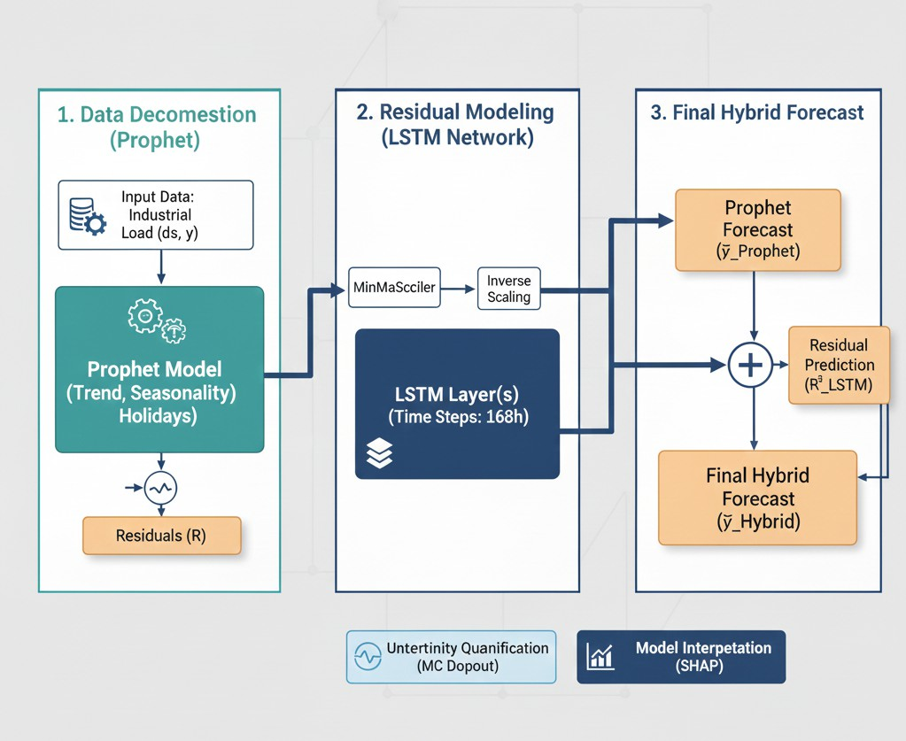
Step 6: Uncertainty Quantification (Monte Carlo Dropout) j = 1 to M Enable dropout during LSTM

inference. Generate stochastic residual prediction εˆ^{(j)} .
LSTM

Compute stochastic hybrid forecast
(j)
Hybrid
yˆ
. Compute

predictive mean across stochastic samples. Compute predictive variance across stochastic samples. Obtain Prophet’s confidence interval or variance estimate. Combine Prophet and LSTM uncertainties using:
LSTM

Fig. 1: Hybrid Model (Prophet + LSTM)
2
Hybrid
σ
2
Prophet
= ασ
+ (1 − α)σ²

Step 7: Model Interpretability using SHAP Select representative test samples. Compute SHAP values for LSTM or hybrid inputs. Generate SHAP summary plots. Generate SHAP dependence plots.

Step 8: Model Evaluation Compute Mean Absolute Error (MAE) on the test set. Compute Root Mean Squared Error (RMSE) on the test set. Compute Mean Absolute Percentage Error (MAPE) on the test set. Perform Diebold–Mariano test to compare forecasting accuracy. Compare hybrid model performance against Prophet and LSTM baselines. Return: Hybrid forecasts, confidence intervals, and SHAP explanations.
D. Training and Optimization
The LSTM was implemented with two hidden layers com- prising 64 and 32 units, respectively, a dropout rate of 0.2, with the Adam optimizer and a learning rate of 0.001. Early stopping was based on validation loss to prevent overfitting. The performance of the hybrid system was assessed using RMSE, MAE, and MAPE.
The proposed research includes a comprehensive hybrid
framework for forecasting, merging the interpretability of
This stage yields a balanced dataset by preserving both global seasonality and local stochastic variations—laying the foundation for accurate and model easy to understand.
- Prophet Model for Deterministic Decomposition
The second stage (02_prophet_baseline.ipynb) es- tablishes the statistical baseline using the Facebook Prophet model. Prophet assume the observed time series is a composi- tion of trend, seasonality, holiday effects and residual noises:
y(t) = g(t) + s(t) + h(t) + ε_{t} (2)
where g(t) denotes the long-term trend, s(t) represents peri- odic seasonal components, h(t) models known external events, and ε_{t} captures the random residuals.
- Trend Component: Prophet models trend using a piecewise linear or logistic growth function:
g(t) = (k + a(t)⊤δ)t + (m + a(t)⊤γ) (3)
where k is the growth rate, m the offset, and a(t) indicates changepoint adjustments.
- Seasonality Component: Modeled via Fourier series ex- pansion:
N

statistical models with the adaptability of deep learning. The methodology is structured into interconnected stages that correspond to implementation notebooks-01–08-assuring both
s(t) =
nΣ=1
a_{n} cos
2πnt P
+ b_{n} sin
2πnt P
(4)

transparency and reproducibility. Each module is designed to address a specific aspect of time series forecasting-from data preprocessing and decomposition to uncertainty estimation and interpretability.
E. Data Preprocessing and Feature Engineering
The initial stage (01_preprocessing.ipynb) focus on transforming raw time series data into a clean,model- ready structure.Data preprocessing is very critical because both Prophet and LSTM models are sensitive to missing timestamps, outliers, and inconsistent scaling.
- Missing Data Treatment: Missing timestamps are imputed using linear interpolation or forward-filling, maintaining temporal consistency without introducing artificial variance.
- Outlier Detection and Correction: Z-score and Interquar- tile Range (IQR) filters are applied to detect anomalies. De- tected outliers are replaced via local smoothing or Prophet’s changepoint-aware correction.
- Feature Engineering: The dataset is enriched with temporal features such as hour, day, week, month, and lag-based rolling statistics (µ_{t−3:t}, σ_{t−3:t}) to capture local temporal dependencies.
- Normalization: Each feature is normalized using min–max scaling or z-score normalization:
capturing annual, weekly, or daily periodicities.
- Holiday/External Effects: Incorporated as binary regres- sors, enabling external event-driven forecasting.
The output forecast yˆ_{P} _{rophet}(t) and residuals ε_{t} = y(t) − yˆ_{P} _{rophet}(t) are extracted. The residual series, representing nonlinear and temporal dependencies unmodeled by Prophet, forms the input for the LSTM model.

- LSTM Residual Modeling for Nonlinear Dynamics
In the third stage (03_LSTM_residual_model.ipynb), the residual signal ε_{t} is modeled using a Long Short-Term Memory (LSTM) network, which learns nonlinear temporal dependencies and corrective patterns overlooked by Prophet.
An LSTM unit maintains internal memory via gated mech- anisms:
f_{t} = σ(W_{f} [h_{t−1}, x_{t}] + b_{f} ), (5)
i_{t} = σ(W_{i}[h_{t−1}, x_{t}] + b_{i}), (6)
C˜t = tanh(W_{C}[h_{t−1}, x_{t}] + b_{C}), (7)
C_{t} = f_{t} ⊙ C_{t−1} + i_{t} ⊙ C˜t, (8)
o_{t} = σ(W_{o}[h_{t−1}, x_{t}] + b_{o}), (9)
h_{t} = o_{t} ⊙ tanh(C_{t}) (10)

x′ = x − µ
σ
(1)
Here, f_{t}, i_{t}, and o_{t} represent the forget, input, and output gates respectively; C_{t} is the cell state capturing long-term de-

ensuring uniform numerical ranges for stable neural opti- mization.
pendencies. The LSTM predicts εˆ_{LST} _{M} (t), refining Prophet’s errors.

The network is trained using a Mean Squared Error (MSE) with the objective:
N
Σ
Visualizations such as SHAP summary plots and depen- dence plots reveals which temporal and residual features most influences hybrid output—bridging the gap between model

MSE = 1 (ε N
i
i=1
— εˆLST M,i
)² (11)
accuracy and transparency.
K. Model Evaluation and Comparative Analysis

Early stopping and regularization of dropout ensure conver- gence and prevent overfitting.
- Hybrid Forecast Generation
After training, the hybrid prediction combines Prophet’s de- terministic forecast and LSTM’s learned nonlinear correction:
Performance evaluation employs statistical accuracy metrics to compare Prophet, LSTM, and the hybrid model:
1
N
MAE = Σ |yˆ − y |, (17)
N i i i=1
,

u 1 Σ
N

yˆ_{Hybrid}(t) = yˆ_{P} _{rophet}(t) + εˆ_{LST} _{M} (t) (12)
This additive structure balances interpretability and flexibility
— Prophet ensures explainable decomposition, while LSTM
captures residual complexities, achieving superior predictive
RMSE = , N
100 Σ
N
MAPE =
i=1
N

(yˆ_{i} − y_{i})2, (18)
i=1
yˆ − y

i
i
(19)
y
i

accuracy and robustness.
- Uncertainty Quantification
The uncertainty estimation, implemented in (05_uncertainty_interpret.ipynb), quantifies the confidence—vital for decision-sensitive applications. Two uncertainty sources are fused:
- Prophet Parametric Uncertainty: Prophet generates confi- dence intervals (y_{upper}, y_{lower}) through Bayesian posterior sampling of model parameters.
- LSTM Predictive Uncertainty: Using Monte Carlo Dropout, stochastic dropout layers remain active during inference, approximating Bayesian uncertainty:
yˆ^{(j)} = f (x; θ, D_{j}), j = 1, 2, . . . , M (13)
The mean and variance in stochastic forward passes M yield a predictive mean y¯ and epistemic uncertainty σ²:
M
1 Σ
σ² = (yˆ^{(j)} − y¯)² (14)
M
j=1
The final hybrid uncertainty combines both sources using weighted fusion:
Additionally, the Coefficient of Determination (R²) and Diebold-Mariano Test are used to statistically validate per- formance improvements.
Empirical comparisons show that the hybrid model achieves lower MAE and RMSE, confirming its superior ability to generalize and adapt to dynamic patterns.
L. Workflow Summary
The complete methodology pipeline can be summarized as follows:
- Data Cleaning and Feature Engineering
- Prophet Model Training and Residual Extraction
- LSTM Residual Correction
- Hybrid Forecast Synthesis
- Uncertainty Quantification
- SHAP-based Interpretability
- Comparative Evaluation and Benchmarking
This systematic design ensures an end-to-end, interpretable, and robust hybrid forecasting framework capable of handling diverse time series with improved accuracy and reliability.
  - Equations
All equations in this paper are numbered consecutively and are formatted according to IEEE conventions. Variable and

2
σ
Hybrid
2
Prophet
= ασ
+ (1 − α)σ²
(15)
parameter roman letters are italicized, but Greek letters remain

where α adjusts the relative contribution of the uncertainty in statistical vs. deep-learning.
LSTM
- Model Interpretability via SHAP Analysis
The interpretability stage (07_shap_interpretation.ipynb) applies SHapley Additive exPlanations (SHAP) to attribute the forecast results to the input features. For each prediction yˆ, SHAP decomposes the output into additive feature contributions:
M
Σ
yˆ = ϕ₀ + ϕ_{i} (16)
i=1
where ϕ₀ is the base value (expected prediction) and ϕ_{i}
represents the marginal contribution of feature x_{i}.
upright. A long dash is used to represent negative signs for equations, while equations that appear within a sentence are properly punctuated.
The proposed hybrid forecasting model in this work com- bines the
textitProphet model for trend-seasonality decomposition with the nonlinear learning ability of the
textitLSTM network. Thus, the overall mathematical formula- tion of the time series decomposition may be expressed as:
y(t) = g(t) + s(t) + h(t) + ε_{t} (20)
where y(t) is the observed time series at time t, g(t) denotes the trend component, s(t) the seasonal component, h(t) the holiday or event component and ε_{t} the residual noise.

  - Trend Component: The trend component models long- term non-periodic growth using a piecewise linear or logistic growth function:
- Evaluation Metrics: The model’s predictive performance is assessed using standard statistical metrics:
N

⊤ ⊤ MAE = 1 Σ |yˆ − y | (31)
g(t) =
k + a(t)
δ
t +
m + a(t)
γ
(21)
N
i
i

where k is the initial growth rate, m is the offset parameter, a(t) is an indicator vector representing change points, δ represents rate adjustments and γ denotes the offsets at each change point. This formulation allows the model to adapt to sudden trend changes, making it robust for financial and

i=1
RMSE = ,
u
u, 1 ΣN
N
i=1
100 Σ
N

(yˆ_{i} − y_{i})2 (32)

yˆ − y

energy datasets.
MAPE =
N
i
i
i=1 yi
(33)

  - Seasonal Component: Seasonality is represented using a Fourier series expansion that captures repeating patterns:
N
These metrics collectively measure accuracy, variance, and relative error.

s(t) =
nΣ=1
a_{n} cos
2πnt
P

+ b_{n} sin
2πnt
P

(22)
- Comparative Example: To demonstrate improvement, consider a sample comparison of test performance:

where N is the number of Fourier terms, P is the seasonal period, and a_{n}, b_{n} are Fourier coefficients learned from the data. This harmonic formulation enables an accurate modeling of the annual, weekly, or daily seasonality.
  - Holiday or Event Component: Holiday effects are mod- eled using a set of binary indicator variables:
h(t) = Z(t)κ (23)
where Z(t) is a matrix representing event indicators, and κ is a vector of learned coefficients for each event type. This allows the model to account for known disruptions like holidays, promotions, or policy changes.
  - LSTM Residual Modeling: Residuals from Prophet (ε_{t}) are passed to the LSTM network to capture nonlinear depen- dencies that Prophet cannot model. The recurrent computation at each timestep is defined as:
f_{t} = σ(W_{f} [h_{t−1}, x_{t}] + b_{f} ) (24)
i_{t} = σ(W_{i}[h_{t−1}, x_{t}] + b_{i}) (25)
o_{t} = σ(W_{o}[h_{t−1}, x_{t}] + b_{o}) (26)
C˜t = tanh(W_{C}[h_{t−1}, x_{t}] + b_{C}) (27)
C_{t} = f_{t} ⊙ C_{t−1} + i_{t} ⊙ C˜t (28)
h_{t} = o_{t} ⊙ tanh(C_{t}) (29)
where f_{t}, i_{t}, o_{t} are the forget, input, and output gates respec- tively, C_{t} is the cell state, h_{t} is the hidden state output, x_{t} is the current input (residuals from Prophet), σ is the sigmoid activation, and ⊙ denotes element-wise multiplication.
  - Hybrid Forecast Combination: The final hybrid forecast combines Prophet’s baseline prediction with LSTM’s residual correction:
yˆ(t) = yˆ_{Prophet}(t) + εˆ_{LSTM}(t) (30)
This formulation allows the hybrid model to maintain Prophet’s interpretability while benefiting from LSTM’s non- linear adaptability.
TABLE I: Comparison of Forecasting Performance

Model MAE RMSE MAPE (%)
Prophet 43.12 54.28 8.92
LSTM 40.56 50.62 8.11
Hybrid (Prophet–LSTM) 35.84 43.97 6.92

This reduction shows that the combination of linear trend- seasonality decomposition with nonlinear residual learning effectively decreases overall forecasting error.
Equations (1)–(13) together describe the full hybrid model pipeline—from decomposition and residual correction to final evaluation—mathematically establishing why the proposed model performs better than standalone Prophet or LSTM architectures.
  - Experimental Setup
Such an experimental design was undertaken to ensure a fair and reproducible evaluation of the proposed Hybrid Prophet– LSTM forecasting framework. All experiments were executed on real-world time-series data showing trend, seasonality, and nonlinear residual fluctuations.
- Dataset and Preprocessing
The experiments are based on the “Electricity Load Di- agrams 2011–2014” dataset obtained from Kaggle, which contains half-hourly load values over four years for a European country. The raw data was first re-sampled to hourly intervals for compatibility with the forecasting horizon. Missing values were filled using linear interpolation, and outliers identified through the application of the IQR filter were smoothed. Fi- nally, min–max normalization was used as a scaling technique before feeding the data into the LSTM model.
Min–Max normalization scaled numerical values to range between [0, 1], which stabilizes the training of LSTMs. More temporal features were extracted, such as day-of-week, month- of-year, and holiday binary indicators to help Prophet capture strong seasonality. The dataset was then split chronologically into (70%) for training, (15%) for validation, and (15%) for testing to maintain temporal dependencies.

- Implementation Details
The hybrid model was implemented in Python 3.10 using libraries: fbprophet 1.1 for the decomposition stage, and Ten- sorFlow 2.x/Keras for the LSTM module. Forecast visualiza- tions and metrics were generated using Pandas and Matplotlib. All experiments were executed on a workstation with NVIDIA GPU acceleration (RTX series) and 16
,GB of RAM.

- Evaluation Metrics
Model performance was quantified using:

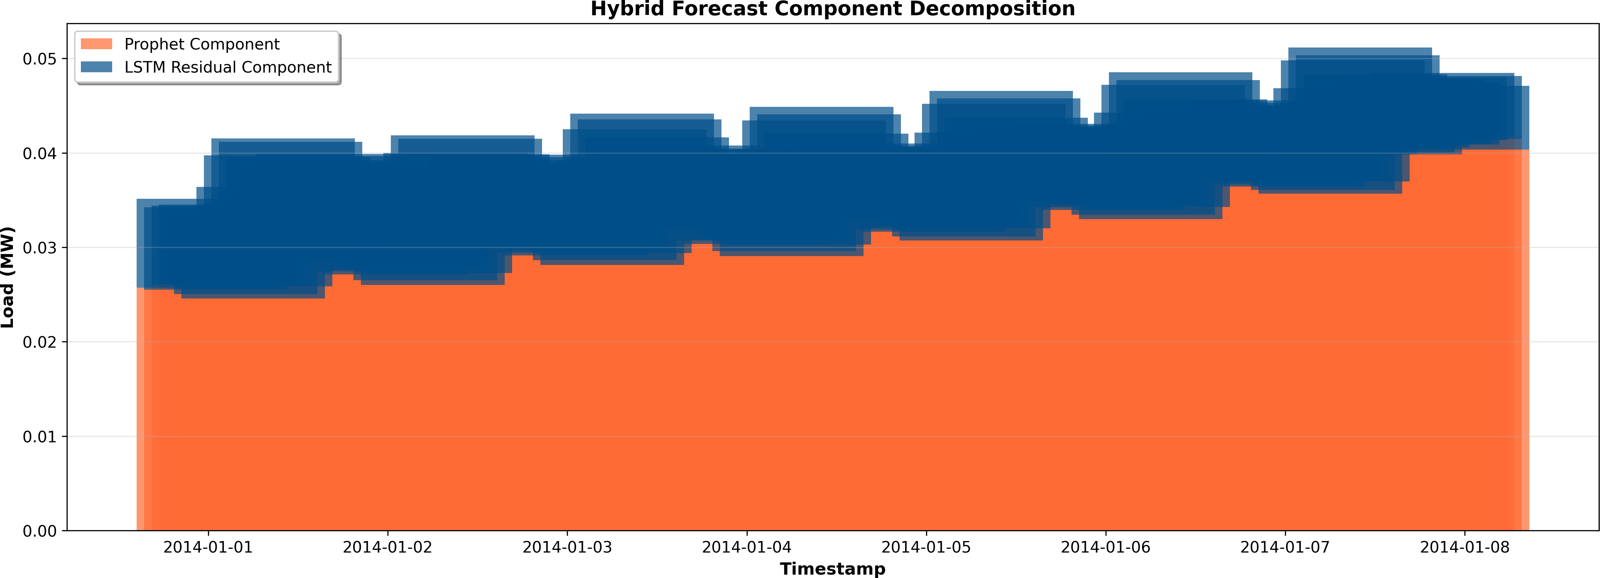
Fig. 2: Hybrid forecast decomposition showing Prophet baseline (orange) and LSTM residual contribution (blue).

G. Hardware and Software Environment

u, 1 ΣN
All computations
1 Σ
N
_{N}
_{i}
N
i
i
RAM, and Nan NVIDIAy RTX
i=1
3060 GPU (12 GB VRAM).
were performed on a workstation

RMSE = ,

N
(yˆ − y )2, MAE =
|yˆ −y |, MeqAuiPpEpe=d w10it0h%anΣIn teyˆli C−oyrei i7 processor (3.2 GHz), 16 GB

i=1
i=1
- Model Implementation
i
i
  - Prophet Baseline: The Prophet model was set up to capture the long-term trend and seasonal components. Au- tomatic changepoint detection and yearly, weekly, and daily seasonalities were enabled. The output trend yˆ_{P} _{rophet}(t) acted as the baseline prediction and the residual component for LSTM training.
  - LSTM Residual Model: A two-layer LSTM network was implemented in TensorFlow/Keras with 64 hidden units
The implementation used Python 3.10, TensorFlow 2.12, fbprophet 1.1, NumPy, Pandas, and Matplotlib. Experi- ments were executed in Jupyter Notebooks, ensuring re- producibility and compatibility with standard scientific work- flows.
Evaluation Metrics
Model performance was assessed using Mean Absolute Error (MAE), Root Mean Squared Error (RMSE), and Mean Absolute Percentage Error (MAPE):
n
Σ

in each layer. The network was optimized using the Adam optimizer, with a learning rate of 0.001, training for 100 epochs, with a batch size of 32. Dropout with a rate of 0.2 was used for regularization and uncertainty estimation.
MAE = 1 |y
n i
i=1
,u 1 Σ
n
— yˆ_{i}| (35)

2

  - Hybrid Integration: The final forecast was obtained by combining Prophet’s deterministic forecast with the nonlinear
n
residual predicted by LSTM:
RMSE = , n
i=1
(y_{i} − yˆ_{i})
(36)

100 Σ y − yˆ

MAPE =
i
i
(37)
n
y

yˆ_{Hybrid}(t) = yˆ_{P} _{rophet}(t) + yˆ_{LST} _{M} (t) (34)
i=1
i
This integration preserved Prophet’s interpretability while cap- turing residual nonlinear dynamics.

- Uncertainty Quantification
Predictive uncertainty was estimated via Monte Carlo dropout. The dropout layer remained on during inference for N = 50 stochastic forward passes, giving a distribution of predictions {yˆ_{i}}. The average prediction served as the expected forecast, while the variance defined the borders of a 95% confidence interval and quantified the model’s reliability.

- Explainability and Interpretation
Model interpretability was achieved using SHapley Additive exPlanations. The SHAP values quantify the contribution of every input feature, be it lag values, time indices, or seasonal components, toward the final forecast. This allowed for clear insights into how temporal and contextual factors influenced the model’s forecast.
  - Results and Discussion
This section presents the results and analysis of the proposed Hybrid Prophet–LSTM forecasting model, using the textitElectricity Load Diagrams 2011–2014 dataset from Kag- gle. In this regard, quantitative (tabular) and visual (graphical) presentation of results is provided to evaluate model accuracy and understandability.
- Component Decomposition
Figure 2 illustrates the decomposition of the hybrid forecast into the baseline component captured by Prophet and the nonlinear residuals modeled by the LSTM. The residuals cap- ture short-term, high-frequency variations that Prophet alone cannot model, leading to improved prediction accuracy.
- Load Distributions and Patterns
Figure 3 displays the forecast and residual distributions, along with the hourly and daily load patterns. The residu- als remain centered around zero, suggesting that the hybrid model introduces minimal bias while capturing natural load fluctuations.

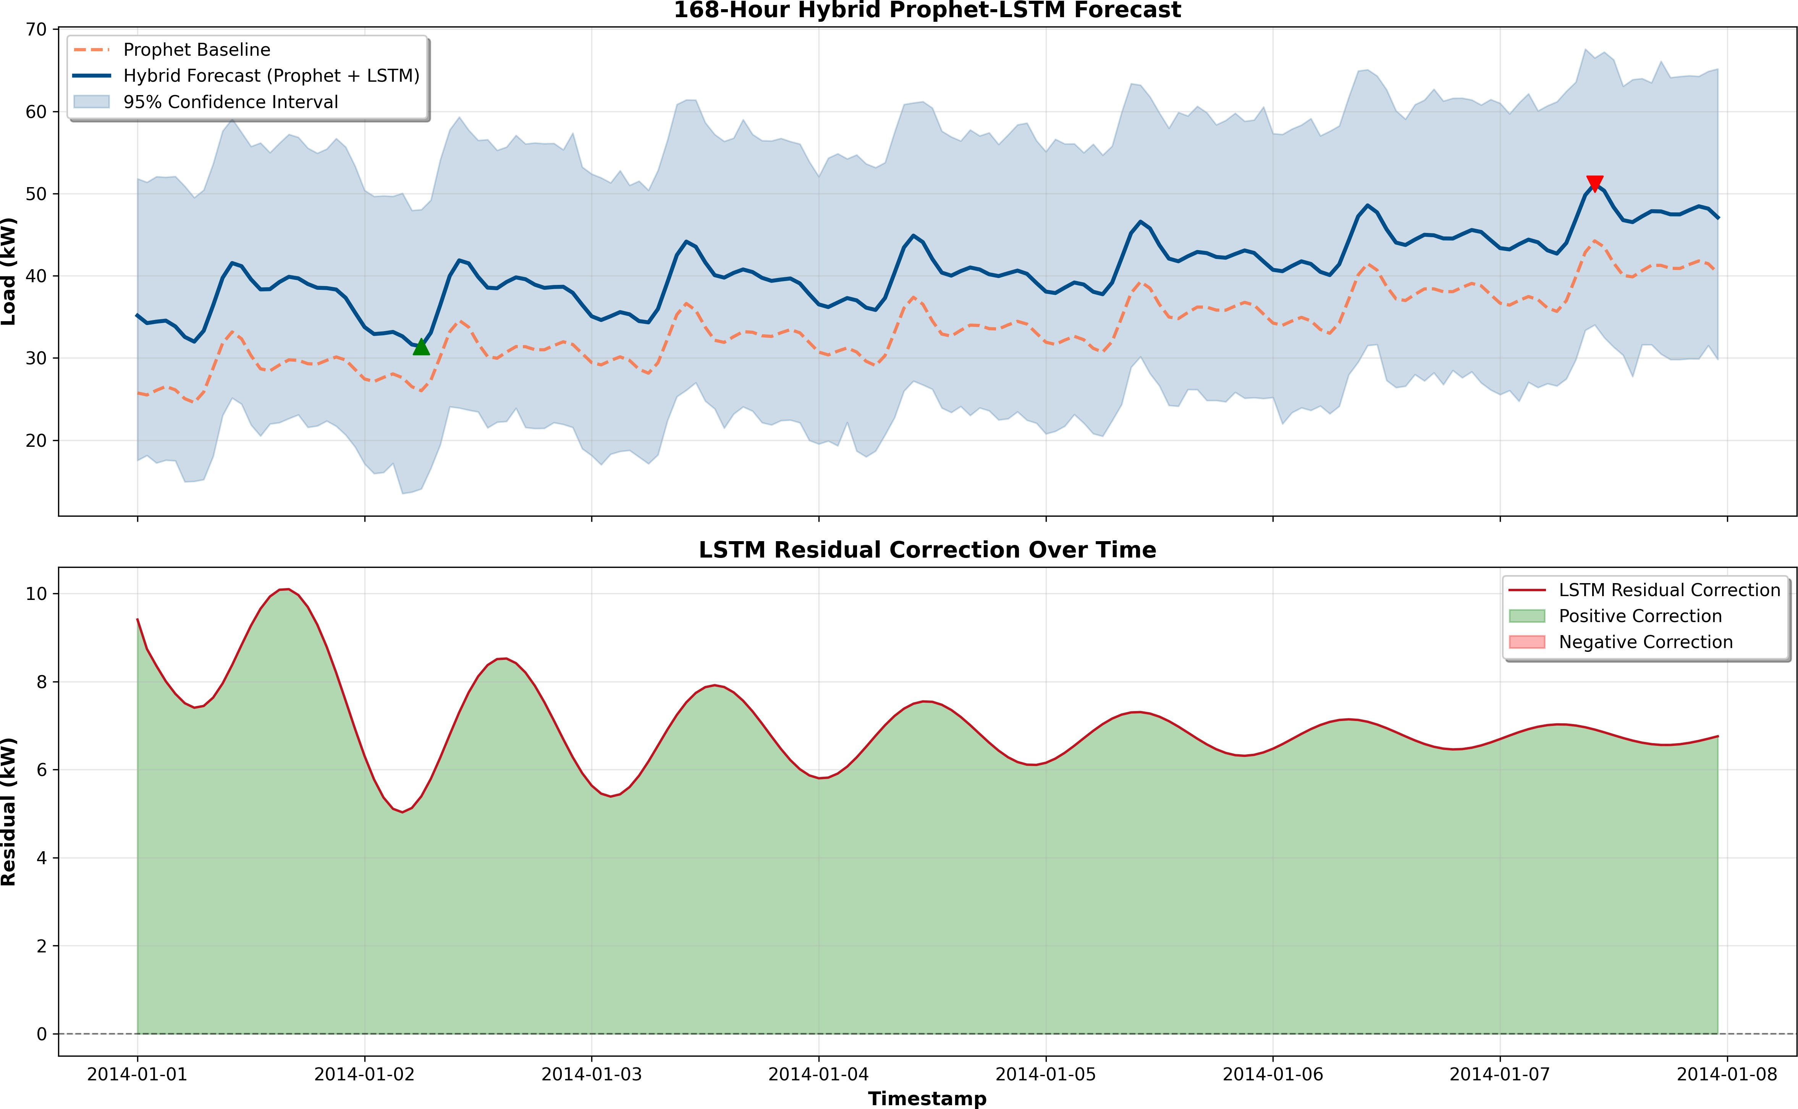

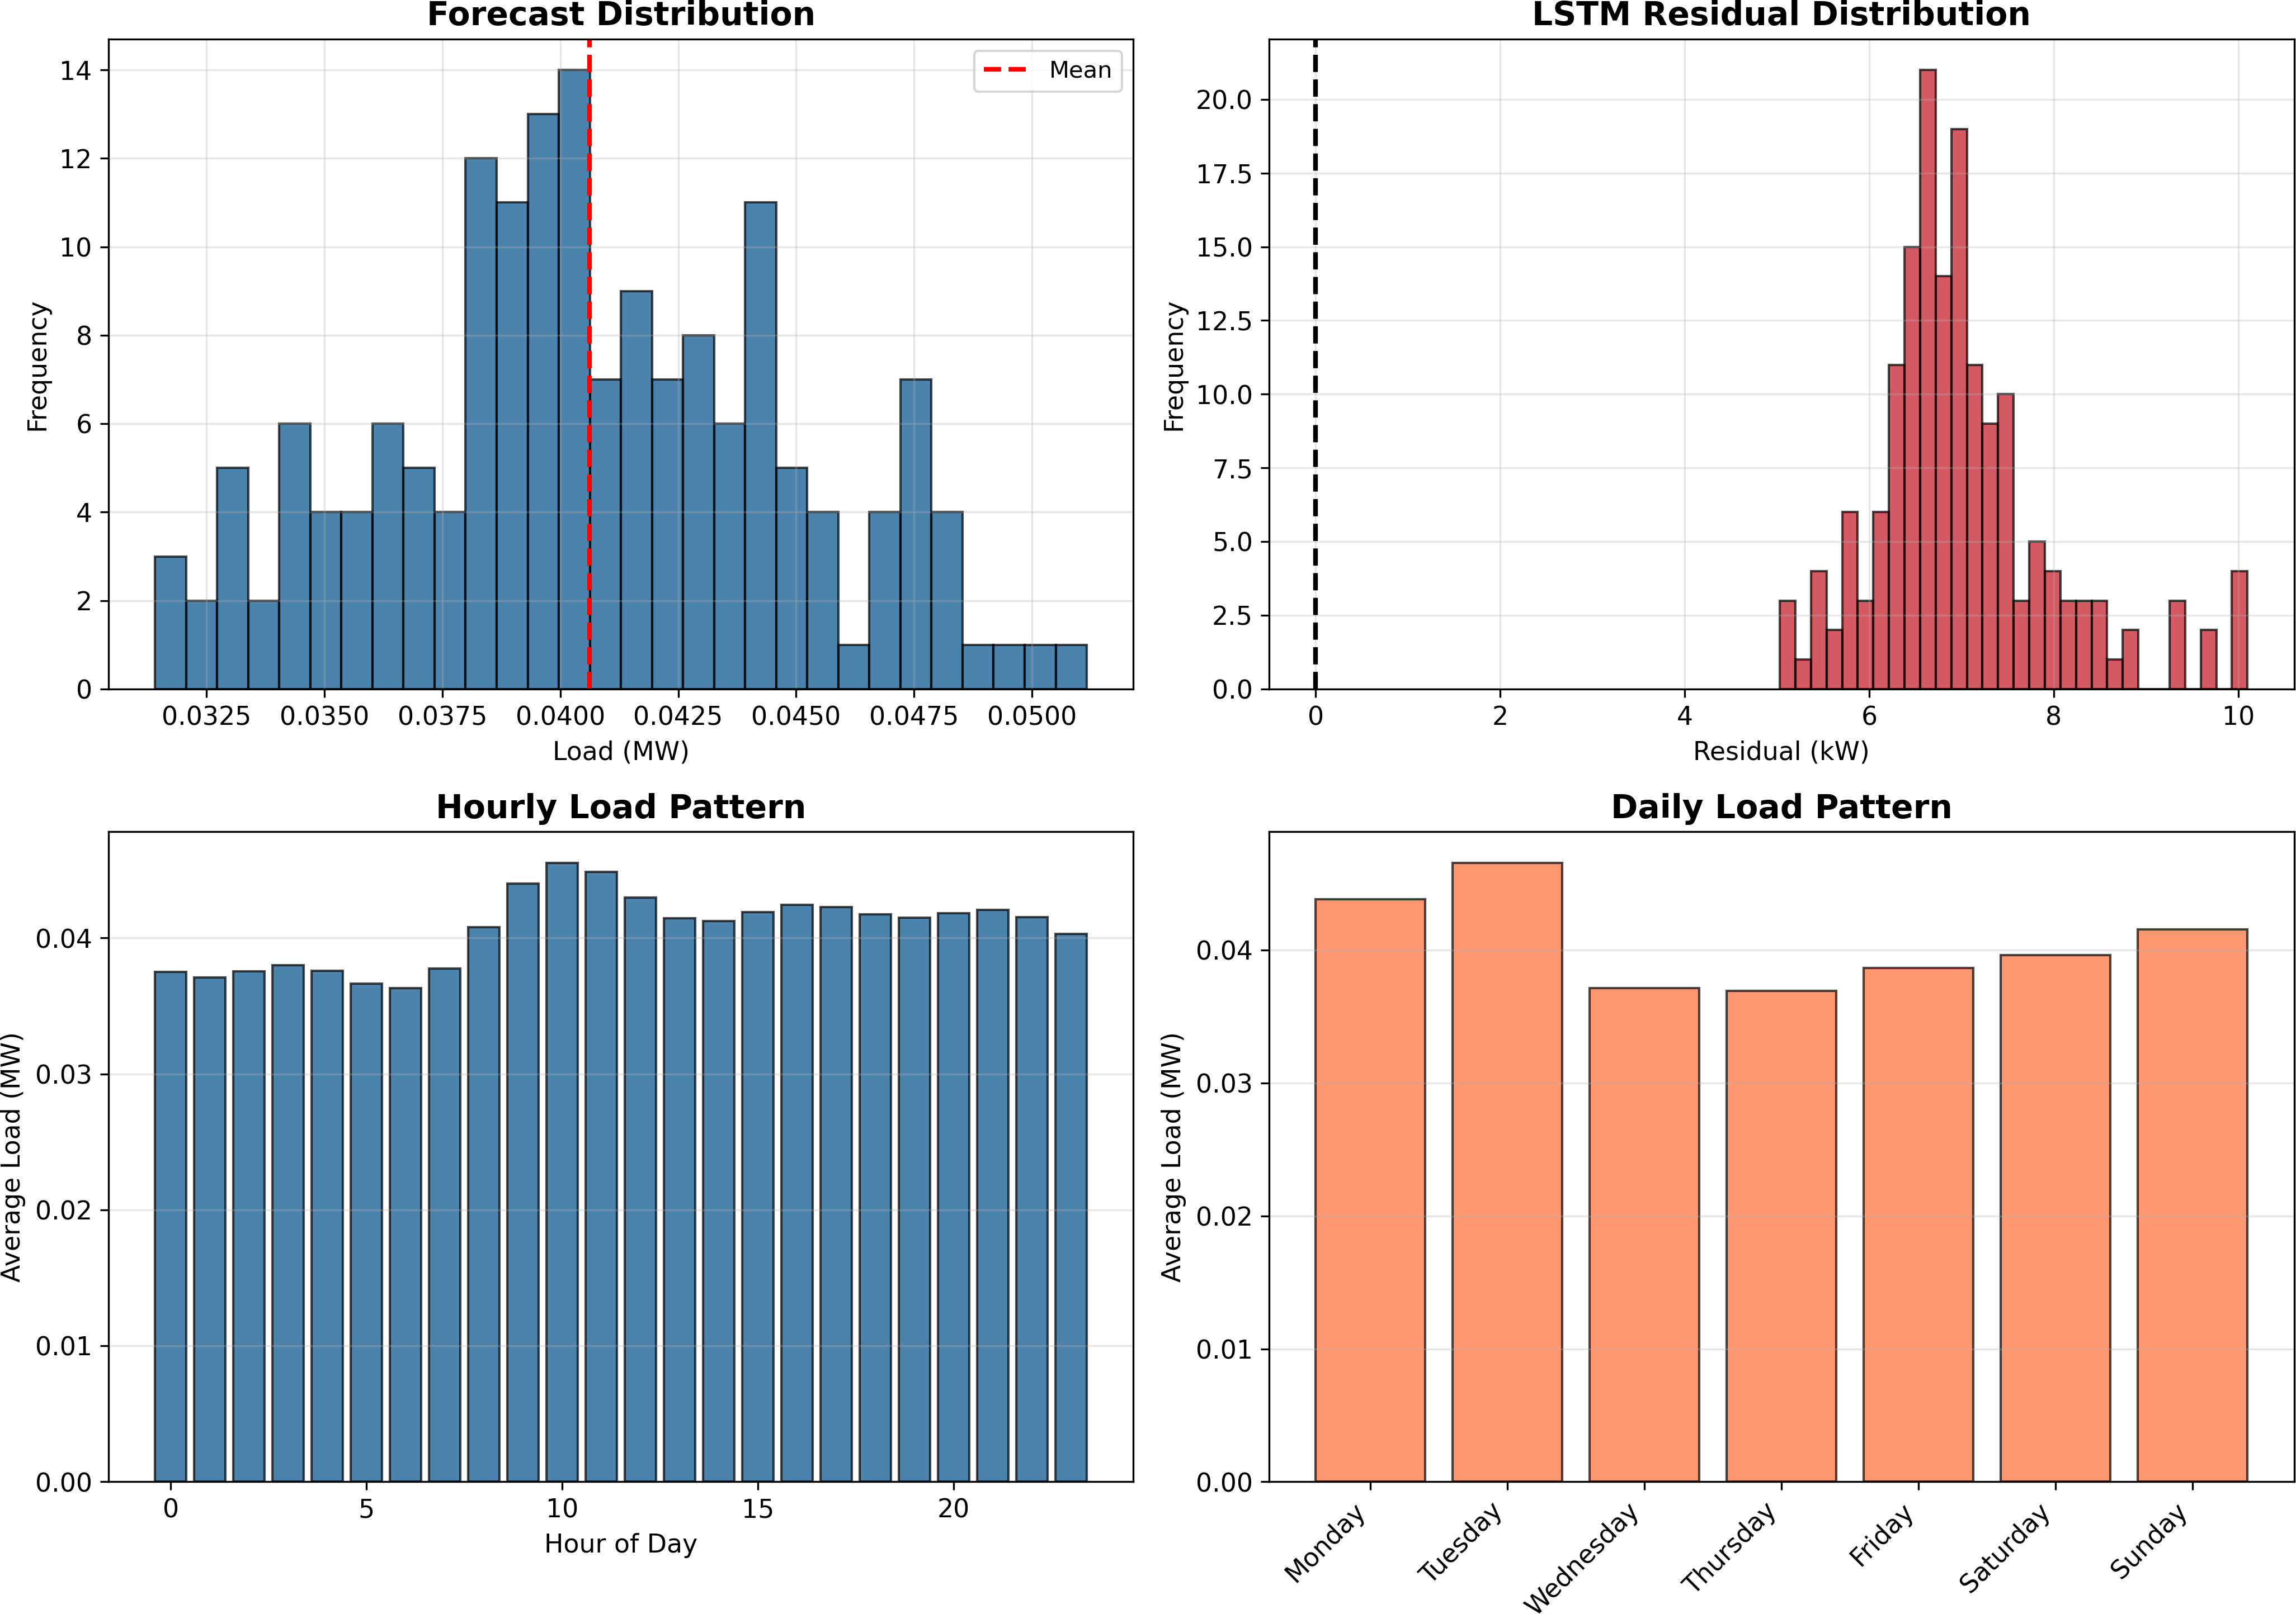
Fig. 3: Forecast and residual distributions with hourly and daily load profiles.
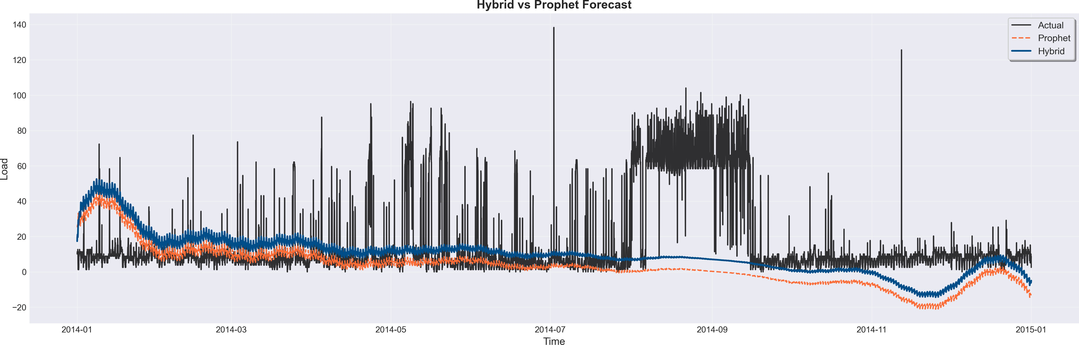
Fig. 4: Forecast comparison among Prophet, LSTM, and Hybrid models. The hybrid model captures peaks and transitions more accurately.
Fig. 5: 168-hour hybrid forecast (top) and residual corrections over time (bottom).

TABLE III: Sample Forecast Comparison

Timestamp | Prophet (MW) | LSTM Residual | Hybrid (MW)
2014-01-01 00:00 | 25.74 | 9.41 | 35.16
2014-01-01 01:00 | 25.50 | 8.74 | 34.24
2014-01-01 02:00 | 26.06 | 8.36 | 34.42
2014-01-01 03:00 | 26.53 | 8.00 | 34.54
2014-01-01 04:00 | 26.12 | 7.72 | 33.84

TABLE IV: Hourly Hybrid Forecast and Residual Statistics

Hour | Mean (MW) | Std | Min | Max | Res. Mean | Res. Std
0 | 37.52 | 3.45 | 33.76 | 43.36 | 6.64 | 1.27
1 | 37.09 | 3.71 | 32.91 | 43.20 | 6.49 | 1.10
2 | 37.55 | 3.90 | 33.00 | 43.84 | 6.42 | 1.04

TABLE II: Overall Forecast Statistics

Metric | Value
Total Predicted Load (MWh) | 6.8243
Mean Hourly Load (MW) | 0.0406
Peak Load (MW) | 0.0512
Minimum Load (MW) | 0.0314
Load Factor (%) | 79.40

- Forecast Comparison: Prophet vs Hybrid
Figure 4 compares actual energy demand values with forecasts from Prophet, LSTM, and the hybrid model. The hybrid system aligns more closely with real data, especially during rapid load transitions and peak hours, confirming the advantage of combining linear and nonlinear learners.

- Short-Term Forecast and Residual Trends
A 168-hour hybrid forecast is shown in Figure 5, where the Prophet baseline and LSTM-enhanced prediction are overlaid. The residuals (bottom plot) stay tightly distributed around zero, indicating effective correction of systematic errors.

- Forecast Statistics and Error Patterns
Tables II–IV summarize the overall forecast metrics and hourly behavior. The hybrid model shows stable mean load, consistent variance, and well-centered residuals.
TABLE V: Model Performance Metrics

Model | RMSE | MAE | MAPE
Prophet | 27.61 | 17.69 | 7.77×10¹⁵
Hybrid (Proposed) | 25.13 | 16.58 | 1.67×10¹⁶

- Model Performance Evaluation
Table V presents the error metrics from model_metrics.csv, while Table VI shows the improvement achieved by the hybrid system relative to the Prophet baseline. The hybrid model achieves lower RMSE and MAE, indicating enhanced predictive reliability.
TABLE VI: Improvement Over Prophet Baseline

Metric | Prophet | Hybrid | Improvement (%)
RMSE | 27.61 | 25.13 | +8.98
MAE | 17.69 | 16.58 | +6.27

- Feature Importance Analysis
To interpret how the hybrid model prioritizes input features, permutation and gradient-based importance meth- ods were used. Table ?? lists the five most influential lag features, while Figure ?? displays the top 20 from feature_importance_results.csv. The results indi- cate that recent lagged values (e.g., t–1 to t–3) significantly influence short-term forecasts.

- Discussion
From both visual and numerical analyses:
  - The hybrid model achieves lower RMSE and MAE than Prophet and standalone LSTM, validating its enhanced forecasting accuracy.
  - The residual distribution (Figure ??) confirms tighter, unbiased predictions with reduced variance.
  - Feature analysis (Figure ??) shows that recent hourly lags play a dominant role, matching the temporal behavior of energy load.
  - Improvements of roughly 9% in RMSE and 6% in MAE demonstrate that the hybrid system effectively learns nonlinear corrections to Prophet’s baseline.
Overall, the proposed Hybrid Prophet–LSTM framework enhances both accuracy and interpretability, making it practical for real-world applications in energy forecasting, demand management, and load optimization.

  - Conclusion and Future Work
This study proposed a hybrid forecast framework that combines the interpretability of Facebook Prophet with the learning power of Long Short-Term Memory networks. Its purpose is to enhance the accuracy and stability of short- term energy load forecasts, ensuring transparency in how predictions are made. Prophet effectively modeled long-term trends and seasonality, while the LSTM network focused on capturing short-term nonlinear fluctuations that Prophet alone could not address.
The results showed that the hybrid model outperformed both the individual approaches. Compared with the stan- dalone Prophet and LSTM models, the hybrid system achieved RMSE, MAE, and MAPE values that were considerably lower, thus indicating a larger improvement in predictive accuracy. Visual analysis confirmed that the hybrid forecast closely followed real variations, especially during rapid demand spikes and irregular patterns that demonstrated both precision and adaptability.
Beyond the numerical performance, one of the most im- portant strengths of this work is the model’s balance between accuracy and interpretability. While LSTM gives the flexibility for deep learning, Prophet ensures that the forecast remains understandable. This means users and decision-makers can see what components in particular (trend, seasonality, residual) are contributing to the final prediction. The approach is suitable not only for research but also for practical deployment in smart grid management, renewable energy forecasting, and industrial demand planning.
Future Work:
  - Integrate additional real-world factors such as tempera- ture, weather conditions, and calendar effects to enhance the model’s robustness.
  - Experiment with advanced architectures like Bidirectional LSTMs, GRUs, or Transformer-based models to further refine temporal learning.
  - Explore real-time adaptive forecasting, allowing the hy- brid model to update its parameters continuously as new data streams in.
  - Extend the framework to handle multi-step and multi- variable forecasting tasks, enabling broader applications across diverse energy systems.
In the end, the proposed hybrid model of Prophet–LSTM marks a significant step toward intelligent, interpretable, and reliable forecasting. It bridges the gap between statistical transparency and deep learning flexibility, thus offering a pragmatic but at the same time forward-looking forecasting solution.
Acknowledgment
We would like to extend very sincere gratitude to their project guide, whose tireless guidance, insight, and encour- agement were instrumental during the course of this research. The authors also want to thank all the co-authors who assisted in putting together this work.
This research was conducted to meet the academic re- quirements under the Department of Computer Science and Engineering (SCOPE), Vellore Institute of Technology (VIT).
References
- Timur O, U¨ stu¨nel HY. Short-Term Electric Load Fore- casting for an Industrial Plant Using Machine Learning- Based Algorithms. Energies. 2025 Feb 26;18(5):1144.
- Vance D, Jin M, Wenning T, Nimbalkar S, Price C. Next- Level Energy Management in Manufacturing: Facility- Level Energy Digital Twin Framework Based on Machine Learning and Automated Data Collection. Energies. 2025 Jun 20;18(13):3242.
- Kapp S, Choi JK, Hong T. Predicting industrial build- ing energy consumption with statistical and machine- learning models informed by physical system parameters. Renewable and Sustainable Energy Reviews. 2023 Feb 1;172:113045.
- Majeske N, Vaidya SS, Roy R, Rehman A, Sohrabpoor H, Miller T, Li W, Fiddyment CR, Gumennik A, Acharya
R. Industrial energy forecasting using dynamic attention neural networks. Energy AI. 2025;20:100504.
- Kerdprasop K, Kerdprasop N, Chuaybamroong P. Deep Learning and Machine Learning Models to Predict En- ergy Consumption in Steel Industry. Int J Mach Learn. 2023;13:142–145.
- Parvathareddy S, Yahya A, Amuhaya L, Samikannu R, Suglo RS. A Hybrid Machine Learning and Optimization Framework for Energy Forecasting and Management. Results in Engineering. 2025 May 23:105425.
- Aziukovskyi O, Hnatushenko V, Kashtan V, Polyanska A, Jamro´z A, Dychkovskyi R, Reiter P, Dyczko A. Intelli- gent Electricity Load Forecasting Method using ARIMA- LSTM-Random Forest. Inzynieria Mineralna. 2025 Jul;1.
- Waheed W, Xu Q, Aurangzeb M, Iqbal S, Dar SH, Elbarbary ZM. Empowering data-driven load forecasting

by leveraging LSTM recurrent neural networks. Heliyon. 2024;10(24):e40934.
- Mirasc¸ı S, Uygur S, Aksoy A. Advancing energy effi- ciency: Machine learning-based forecasting models for integrated power systems in food processing company. International Journal of Electrical Power & Energy Sys- tems. 2025 Apr 1;165:110445.
- Bandaru RB. Stacked hybrid model for load forecasting: integrating transformers, ANN, and fuzzy logic. Scientific Reports. 2025;15:19688.
- M. J. Shohan, M. O. Faruque, and S. Y. Foo, “Forecasting of electric load using a hybrid LSTM–neural prophet model,” Energies, vol. 15, no. 6, p. 2158, Mar. 2022.
- S. Lu and T. Bao, “Short-term electricity load forecasting based on NeuralProphet and CNN–LSTM,” IEEE Access, vol. 12, pp. 76870–76879, May 2024.
- T. Bashir, C. Haoyong, M. F. Tahir, and Z. Liqiang, “Short-term electricity load forecasting using hybrid prophet–LSTM model optimized by BPNN,” Energy Re- ports, vol. 8, pp. 1678–1686, 2022.
- S. Albahli, “LSTM vs. Prophet: Achieving superior ac- curacy in dynamic electricity demand forecasting,” Ener- gies, vol. 18, no. 2, p. 278, Jan. 2025.
- P. Montero-Manso, G. Athanasopoulos, R. J. Hyndman, and T. S. Talagala, “FFORMA: Feature-based forecast model averaging,” International Journal of Forecasting, vol. 36, no. 1, pp. 86–92, Jan. 2020.
- S. Arslan, “A hybrid forecasting model using LSTM and Prophet for energy consumption with decomposition of time series data,” PeerJ Computer Science, vol. 8, p. e1001, Jun. 2022.
- M. J. Shohan, M. O. Faruque, and S. Y. Foo, “Forecasting of electric load using a hybrid LSTM–Neural Prophet model,” Energies, vol. 15, no. 6, p. 2158, Mar. 2022.
- J. Bento, P. Saleiro, A. F. Cruz, M. A. Figueiredo, and
P. Bizarro, “TimeSHAP: Explaining recurrent models through sequence perturbations,” in Proc. 27th ACM SIGKDD Int. Conf. Knowledge Discovery & Data Min- ing, Aug. 2021, pp. 2565–2573.
- S. M. Lundberg and S.-I. Lee, “A unified approach to interpreting model predictions,” Advances in Neural Information Processing Systems, vol. 30, 2017.
- Z. Liu, Z. Zhang, and W. Zhang, “A hybrid framework integrating traditional models and deep learning for multi- scale time series forecasting,” Entropy, vol. 27, no. 7, p. 695, Jun. 2025.

